**1.jenkins安装步骤：**

1.安装tomcat，参考rap那篇文档

2.安装jdk，参考rap那篇文档

3.安装jenkins，从jenkins官网下载war包，放入tomcat的webapps目录。本次安装的jenkins版本为2.32.2

4.安装jenkins插件，把下载的插件文件.hpi文件放入/root/.jenkins/plugins目录下，从jenkins官网下载gradle和structs（gradle依赖的插件）

5.安装矩阵认证策略插件Matrix Authorization Strategy和Icon Shim、Folders、Credentials插件，有些是可选的

6.已安装的插件列表如下图

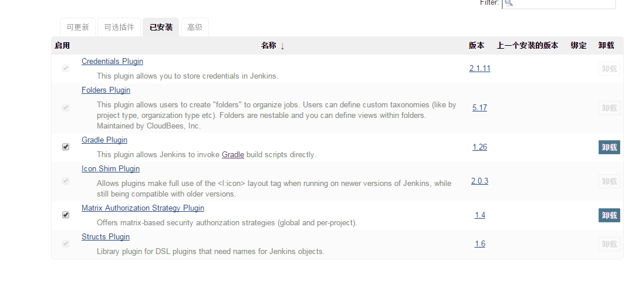

**2.gradle安装步骤：**

1.从官网下载gradle,地址 https://gradle.org/

2.安装步骤如下：

**Install manually**

**Step 1. Download the latest Gradle distribution**

The current Gradle release is version 3.4, released on 20 Feb 2017. The distribution zip file comes in two flavors:

* [Binary-only](https://services.gradle.org/distributions/gradle-3.4-bin.zip)
* [Complete](https://services.gradle.org/distributions/gradle-3.4-all.zip) (with docs and sources)

If in doubt, choose the binary-only version and browse [docs](https://gradle.org/docs) and [sources](https://github.com/gradle/gradle) online.

Need to work with an older version? See the [releases page](https://gradle.org/releases).

**Step 2. Unpack the distribution**

Unzip the distribution zip file in the directory of your choosing, e.g.:

$ mkdir /opt/gradle

$ unzip -d /opt/gradle gradle-3.4-bin.zip

$ ls /opt/gradle/gradle-3.4

LICENSE NOTICE bin getting-started.html init.d lib media

**Step 3. Configure your system environment**

Configure your PATH environment variable to include the bin directory of the unzipped distribution, e.g.:

$ export PATH=$PATH:/opt/gradle/gradle-3.4/bin

**Step 4. Verify your installation**

Run gradle -v to run gradle and display the version, e.g.:

$ gradle -v

------------------------------------------------------------

Gradle 3.4

------------------------------------------------------------

3.安装Android SDK

从这个地址下载适合的文件 http://tools.android-studio.org/index.php/sdk

tar -xzvf解压之，在/etc/profile中增加变量 ANDROID_HOME，在PATH中增加android tool和platform-tools目录的路径

**问题：**

**1.忘记了账号密码或者设置的安全策略不正确，需要删掉/root/.jenkins/config.xml文件中的如下内容，然后重启jenkins**

<useSecurity>true</useSecurity>

<authorizationStrategy class="hudson.security.LegacyAuthorizationStrategy"/>

<securityRealm class="hudson.security.HudsonPrivateSecurityRealm">

<disableSignup>true</disableSignup>

<enableCaptcha>false</enableCaptcha>

</securityRealm>